Task 3: Nessus Vulnerability Scan on Local Host

Objective
The objective of this task is to perform a Nessus vulnerability scan on the local host and analyze the scan results to understand the reported findings.

Scan Details
A Nessus Host Discovery scan was performed on the local system (192.168.135.1). The scan confirms host availability before running deeper vulnerability checks.

Vulnerability Identified
Nessus reported an informational finding titled 'Ping the remote host'. This result indicates that the target system is alive and responding to network requests. Nessus uses techniques such as ICMP, TCP, ARP, and UDP ping to verify host availability.

Severity Level
Severity: Informational (INFO)
This severity level means the finding does not represent a security vulnerability.

Impact Analysis
There is no negative impact associated with this finding. It only confirms that the host is reachable on the network.

Remediation / Fix
This is not a vulnerability and does not require remediation. If necessary, ICMP responses and unnecessary network discovery traffic can be restricted using firewall rules to reduce host visibility.

Proof of Evidence
Screenshots from the Nessus scan output demonstrate that the host is up and responding, confirming successful host discovery.

Conclusion
The Nessus scan successfully verified the availability of the local host. No vulnerabilities were detected in this scan. This confirms that the system is reachable and ready for further security assessments.

Screenshots / Evidence
Screenshot 1: Nessus Host Discovery Scan Summary
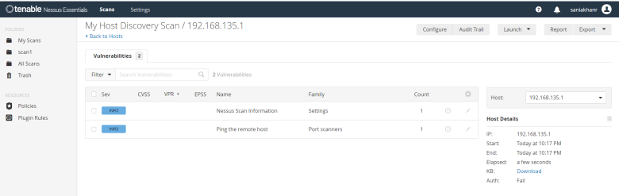
Screenshot 2: Ping the Remote Host – Informational Finding
